SERVER STRESS TEST FOR DDoS ATTACK USING MACHINE LEARNING

ABSTRACT

Attacks on the web servers and web application is the most common form of
attacks that are carried out nowadays. The main reason being is most of the web
application or services are vulnerable to attacks and can be easily compromised.

One of the popular attacks used is DdoS.

DDoS stand for Distributed denial of services. Most recent websites and web
servers are unable to withstand strong attacks like a DDoS attack. These private
servers don't have protection against simple attacks and are easily compromised.
Distributed Denial of Service (DDoS) attacks are the most damaging attacks that
block everyone from using your services. Websites and applications face cyber
threats daily by cyber attackers who want to exploit any IT infrastructure
vulnerability. Once your website or IT infrastructure is compromised, your
business processes and sensitive data face imminent threats that can bring down
your organization. It is vital to test your website and applications for protection
against DDoS attacks.

INTRODUCTION

DDoS attacks happen every day, and most of the time, it is hard to flag the ill-
intended traffic from normal traffic. However, you can be better prepared to
counter and have measures in place so that you can defend your website against
DDoS attacks.

Common Types of DDoS Attacks
A DoS attack can target any component of your network and IT infrastructure.
Attackers look for the opportunity to exploit any vulnerabilities in different layers
of your network.
The following are some common DDoS attacks that we see very often:

Application Layer Attacks
These attacks target your network’s application layer by sending HTTP traffic load
with malicious intent. When an HTTP request comes to the server, to send a
response, the server performs multiple tasks such as load files, querying the
database, computing the request, preparing the response, etc. With such a huge
amount of traffic, the server gets overloaded, and exhausts infrastructure
resources and ultimately goes down. Since it is hard to classify these requests as
malicious requests due to their nature being similar to actual users, the application
layer DDoS attacks are hard to prevent.

Protocol Attacks
These attacks bring down the service by exhausting intermediate resources like
state table capacity, load balancers, firewalls, TCP handshakes, etc. For example,
attackers can send a TCP handshake request for connection initialization, the
server sends back the response and waits for confirmation from the client. But the
client never sends the confirmation, and the server keeps waiting for it, causing the
server resources to exhaust. These attacks are also called state-exhaustion attacks.

Why Perform DDoS Stress Testing

- Identify and resolve website infrastructure issues and bottlenecks before
the DDoS attacks.
- Find out the breaking point for your website under overload conditions
and optimize for robustness.
- Planning for an incident response procedure.
- Devising DDoS mitigation and prevention strategies.
- Scaling and securing IT assets for more resilience.
- Evaluating third-party services for DDoS attack scenario.

PROBLEM STATEMENT

Testing the stress on the server during such attacks and improve the security on
basis of the level of withstanding of website during such attacks as Distributed
Denial of Service (DDoS) attacks are some of the most common, notorious, and
damaging cyber attacks. These attacks cause a great deal of money to
organizations by bringing down their website and interrupting business
processes and consumer service.

LITERATURE SURVEY

Paper | Algorithm | Advantages | Issues | Metrics used
DDoS Attack Detection Method Based on SVM in Software Defined Network | Support vector machine learning algorithm | By sdn experimental environment the detection rate is high and false alarm is low | Very high time complexity | Accuracy
ML Based Application Layer DdoS Attack Detection Using Artificial Neural Networks | Multilayer Perceptron with genetic machine learning algorithm(MLP-GA), Back propagation algorithm | Correct and precise evaluation metric values and has achieved accuracy of 98% | The prevention mechanism is not illustrated in the paper | Accuracy
Ddos Attack Detection and Mitigation Using ML: Methods, Practices and Solutions | Artificial Neural networks, Self organizing map, Fuzzy logic | i)low performance overhead in switches and routers  ii)Not only scales better but also supported by large switch vendors | This Model is not a silver bullet solution to all types of DDoS attacks | i)Entropy  ii)Connection rate
Distributed denial of service attack detection using Naive Bayes and KNN | Navie bayes and k nearest neighbour | The detection rate is high in both knn and naive algorithm | Compared to naive bayes algorithm knn performed with more accuracy | Accuracy
DoS/DDoS Attack Detection Using Artificial Neural Networks | Artificail Neural Network | Detected known ddos attacks with full cent and with unknown it detected upto 95% | it cannot handle DDoS attacks that use encrypted packet headers. | Accuracy
Use the ensemble methods when detecting DoS attacks in Network Intrusion Detection Systems | Bagging, Adaboost and Voting as ensembling qualifier.  NaiveBayes,Random tree and KNN as classifiers | Optimized time complexity and has a metric of 98.76% | NaiveBayes and Random tree classifiers are not best Classifiers | F-score  precision  Accuracy
DDoS Attack Detection Method Based on Machine Learning. | Random forest algorithm Machine learning. | By using machine learning method for the DDoS attack has a good detection rate for the current popular DDoS attacks . It can extract the DDoS attacks out . | Takes time to detect the traffic characteristics with a large proportion. | Packets (TCP, UDP and ICMP) of the DDOS attack tools.
DDoS attack detection method based on improved KNN with DDoS | K-Nearest Neighbors (KNN) algorithm | The algorithms are identified the DDoS attack better, and the algorithms have achieved higher detection rates compared with the existing methods and solutions . | Does not work well with large dataset  Does not work well with high dimensions  Sensitive to noisy data, missing values and outliers | Accuracy
DoS/DDoS Attack Detection Using Artificial Neural Networks | Artificail Neural Network | Detected known ddos attacks with full cent and with unknown it detected upto 95% | it cannot handle DDoS attacks that use encrypted packet headers. | Accuracy
A Survey on Slow DDoS Attack Detection Techniques | Six classifiers of random forest, KNN, logistic regression, SVM, and deep neural networks, CUSUM algorithm | The high detection rate of 99.905% in random forest.  Average attack detection time of 32 seconds.  Ease of implementation, Ease of detection because attacks stress the server’s resources | Only slowloris attack was considered, Only slow header and slow POST were examined | Accuracy and precision
ML method for detecting DDoS attacks in the application layer | Neural Networks Genetic algorithm, Support vector machine (SVM), Fuzzy estimator | shows 95% of attacks generated by the tools have been detected effectively. | High time complexity | Accuracy
Server test for detecting Ddos Attcak: A Hybrid machine learning approach learning approach | SVM,NaiveBayes,KNN and Random frost | Less time complexity | Less accuracy of 93% | Accuracy
Smart Detection: An Approach for DoS/DDoS Attack Detection Using Machine Learning | Random Forest, Logistic Regression, AdaBoost, Stochastic gradient descent, and a perceptron. | i) Low false alarm rate  ii) High accuracy of 96% | i)Need improved hit rate among attack classes  ii)Automatic parameter calibration is missing | Accuraacy

PROPOSED ARCHITECTURE
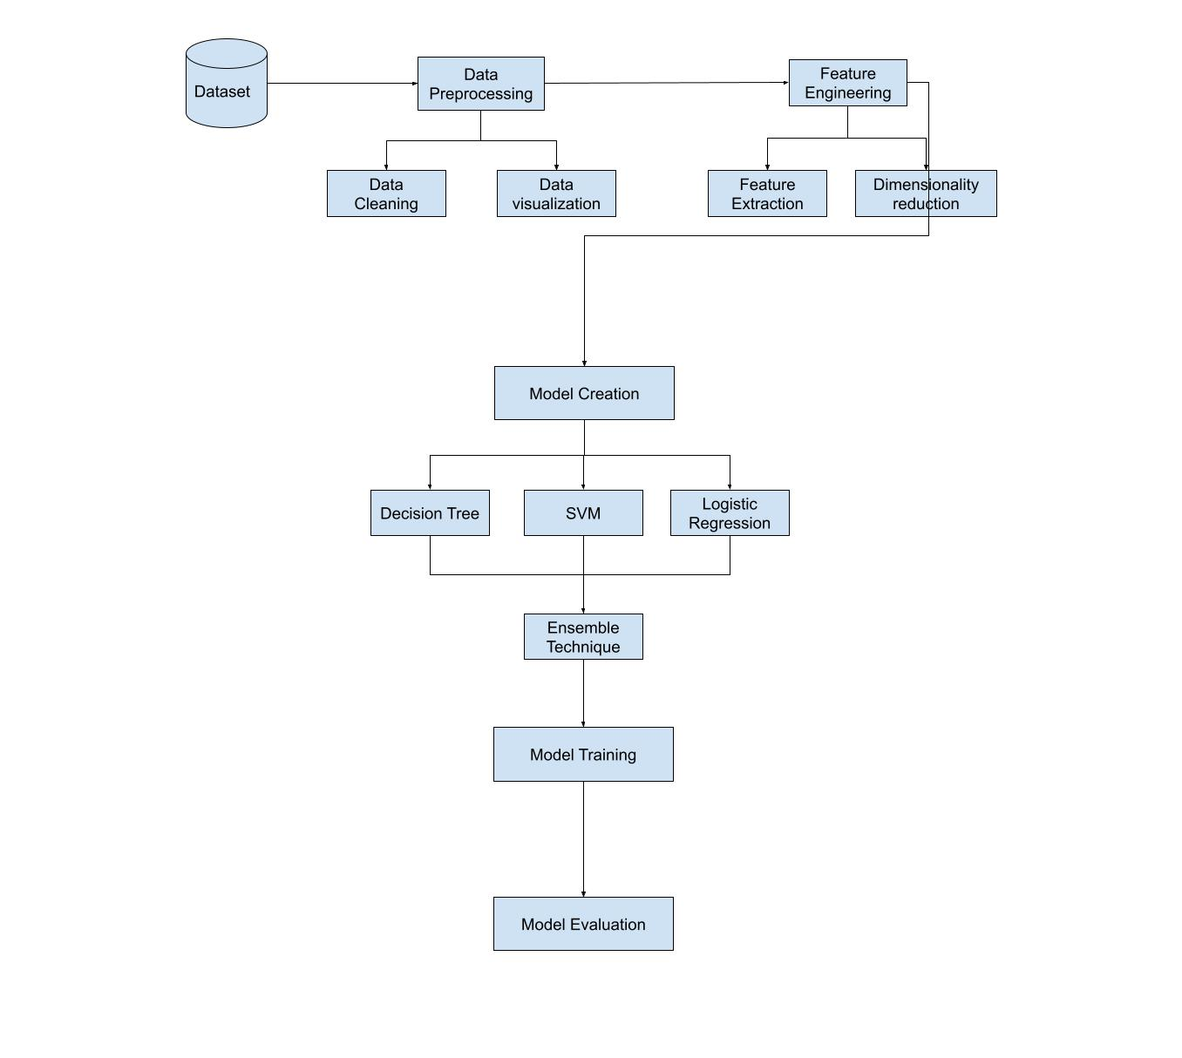

DATASET USED
Application layer Dos Attack dataset from Kaggle which cosist of nearly 700000 rows and 78 columns with one class label.Class lable has three classifications Benign, DosHulk, Dosslowloris.

IMPLEMENTATION
Importing required libraries

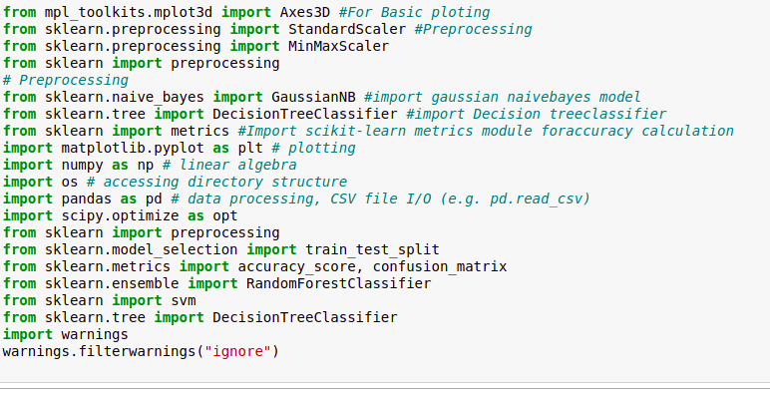

Writing a function for data visulization
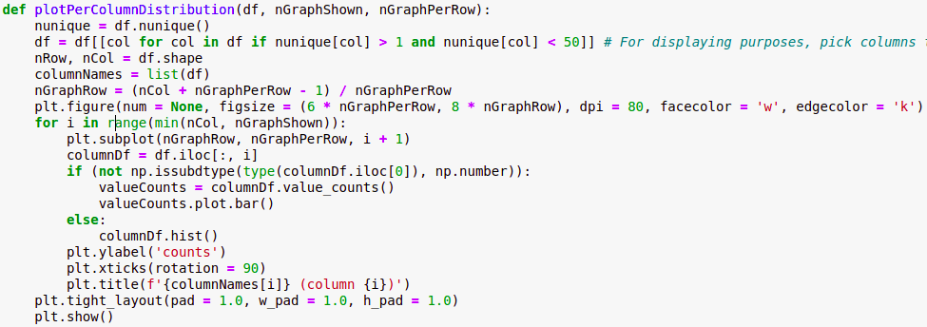

preparing the data
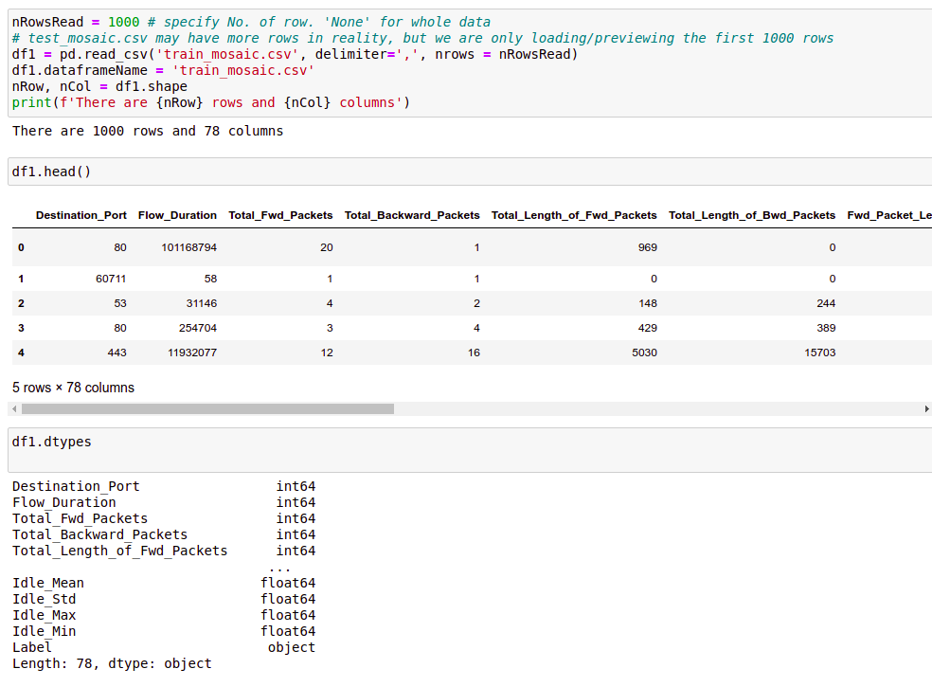
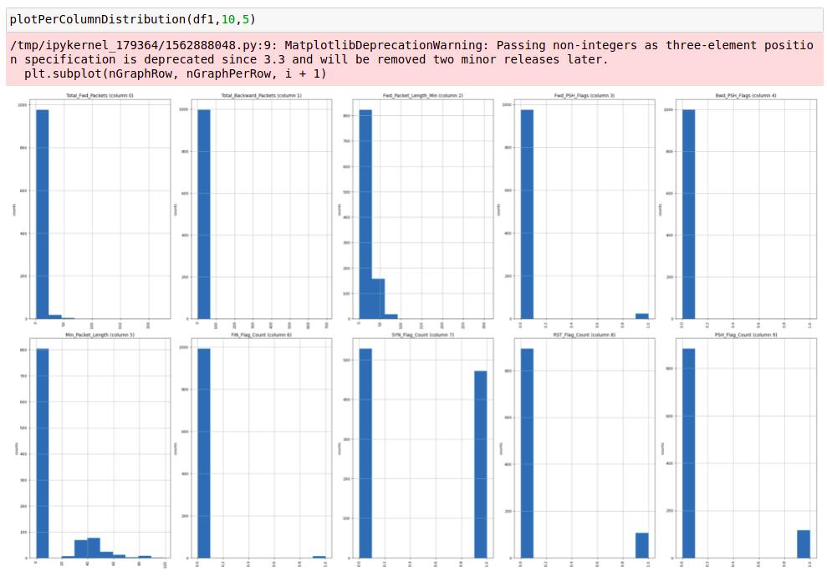
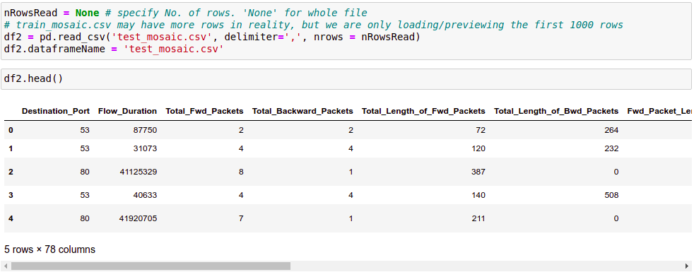

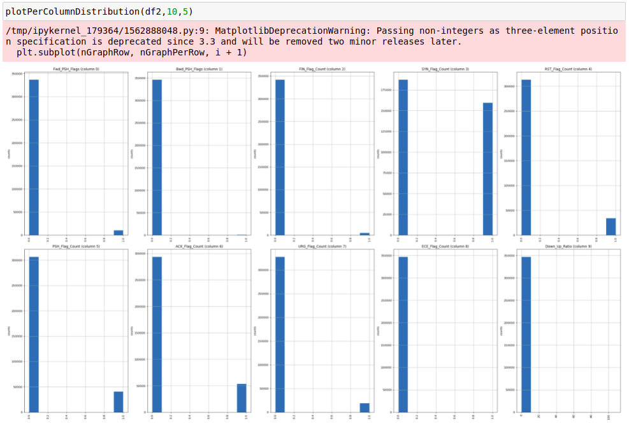
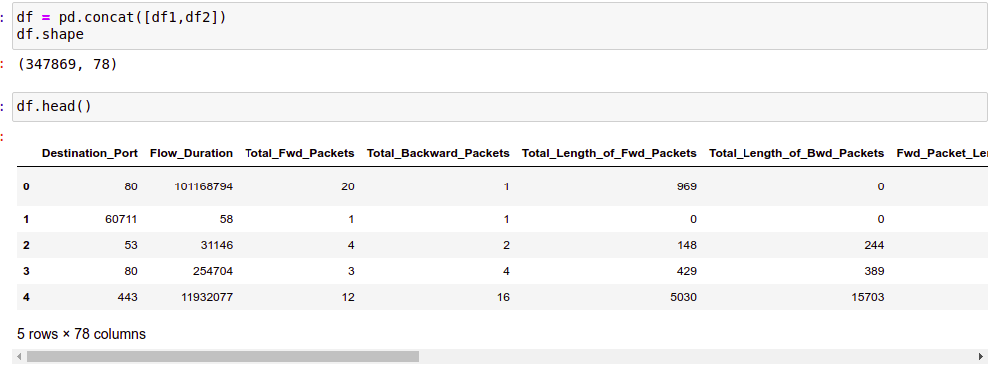

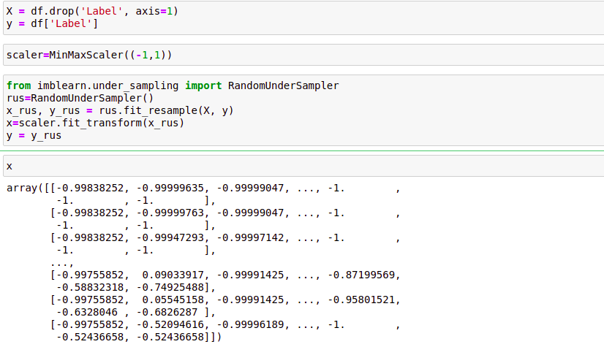

Splitting the data and training
Ensembling Technique:
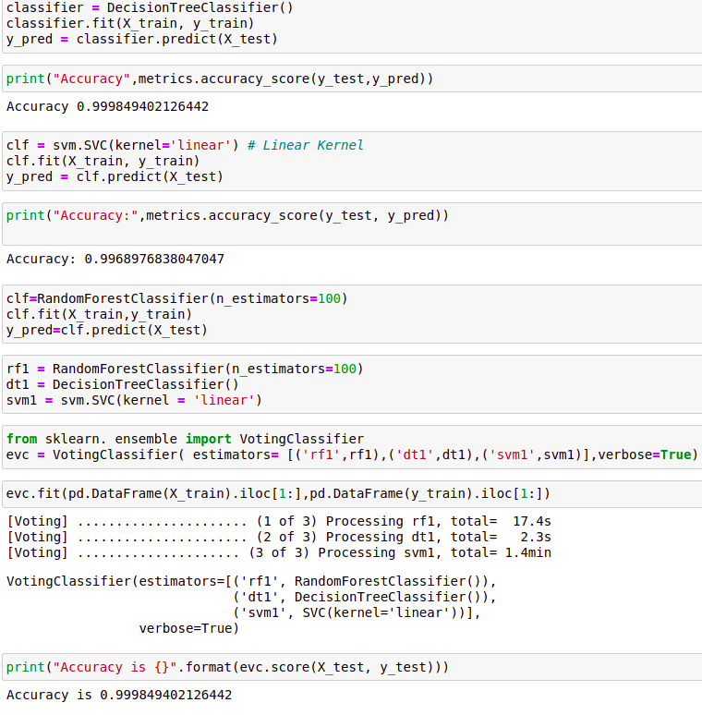

The accuracy of this process is 99.999963%, most accurate method so far.
Since DDoS attacks can bog down your entire IT infrastructure, your employees are not able to access internal resources such as email, VoIP, and other crucial resources for business processes.
From the analysis we can conclude that many IT companies that use DDOS attack tools to test server stress prefer xerxes tool which is most powerful tool compared to slowloris and hulk for the attack and to improve the security.

